Template Explanation
My training program uses Borg’s Rate of Perceived Exertion Scale also known as “RPE.” This scale helps to measure how much effort/weight each movement should be performed at. The weight/effort is based on a rating scale of 6-20. The higher the number, the more you are working. For effort the number reflects how high your heart rate should be during the movement, for weight it reflects how heavy the movement should be performed at. The use of this scale makes it easier for you to understand how hard you should be working.
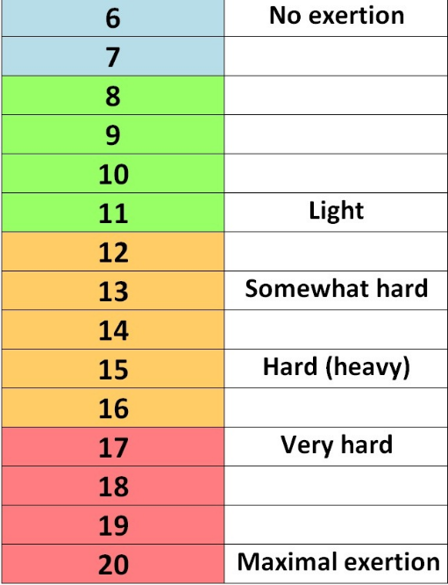
Very rarely will our effort be below 10, only during your cool down phase will your effort be below 10. As shown by the graph, the RPE is the number that will be used on your templates, as you can see there is a breakdown of how intense your movement should be based on your number. 11-13 would be your fat burning zone, 14-16 would be your cardio zone, while 17-20 would be your peak/maximum exertion zone.
Within your program there is a RPE scale to refer to during training, be sure to follow this scale as best as possible for optimal results.
For weight lifting the higher the RPE the more weight for the specified movement. For one person a bench press set of 10 with an RPE 15 may be 225, while others the same movement with an RPE of 15 would be a weight of 145. For this reason I use the RPE to measure your movements instead of giving an actual weight. Be sure to use the proper weight based on your RPE.

Reading Your Program
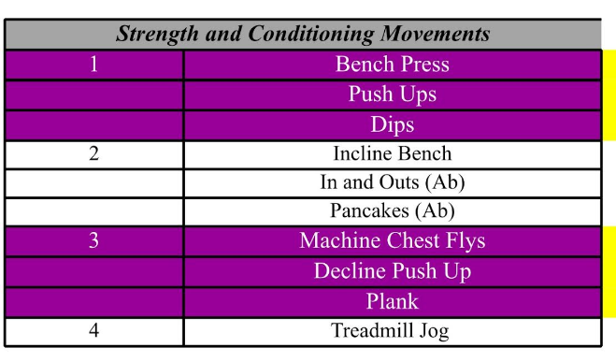
Within each day of training there are color coded sections. Each section may have 2-3 workouts within the colored block. These colored sections are what is known as a “super set.” This means each movement is performed one after another and back to the original after the final movement in the block is completed. For example, in the first section of this block we have bench press followed by pushups and then dips. Only perform these 3 movements and do not move on to the incline bench which is the beginning of the second super set until all sets have been completed for these movements. A set is the amount of times each movement is preformed, so if this block had 2 sets, you would perform these 3 movements twice before moving on to the next block of exercises.
In the following columns, you will see it is broken up into 4 different weeks, this will be your program for the month. Each week is updated with a different amount of sets, reps, RPE and rest periods. Reps are the amount of times each movement is performed. Rest is the amount of time you take before performing the next movement. Some movements such as bench press, squat, and deadlift have percentages instead of RPE, for these simply take the percentage from your one max rep. For example, with a bench press at 75% of your max rep, you would multiply .75 by your max rep. If 225 is your ORM then 75% of that would be around 160.
If you feel your program is not adjusted enough for you or too strenuous be sure to contact me. I take pride in understanding and creating the best programs for your physical capabilities. I am human and make mistakes, so feel free to contact me.

Ready to Get Started?
I hope you are as excited as I am. Before you start be sure to “leave your ego at the door.” It is real easy to injure yourself when performing these movements with more weight than is needed. Always use the appropriate weight and never use more than you can handle. When performing heavy movements ALWAYS have a spotter. If you work out alone and are afraid or to shy to ask someone for a “spot” just think is it worth risking an injury? Even if you feel the weight can be controlled it is better to be safe than sorry. An injury is very serious and can hinder your progress, so be safe.
Be sure to use proper form on every movement, for instructions on proper form checkout my YouTube page. If the form of any movement is not available or still a bit unclear, please contact me. I am here to ensure you get your results safely and learn proper lifting techniques.
If any previous injuries have occurred and you have not stated them to me, please do not perform any movement that could worsen/aggravate the previous injury and contact me right away to change up your programming. It is not being afraid, it is being smart.
Always perform a warm up before going into any workout. While the cardio in your program is a warm up be sure you are loose and ready to go before performing any movement with an RPE over 12.

Safety Precautions
THE USE OF ANY INFORMATION PROVIDED IN THIS EMAIL IS SOLELY AT YOUR OWN RISK. SEEK PROFESSIONAL MEDICAL ADVICE PRIOR TO PARTICIPATING IN OR PRACTICING ANY EXERCISE, MOVEMENT, OR NUTRITIONAL PROGRAM DISCLOSED, SUGGESTED, OR REFERRED TO IN CONNECTION WITH YOUR USE OF THIS COMMUNICATION AND/OR THE PRODUCTS AND SERVICES. YOU SHOULD NOT RELY ON INFORMATION PROVIDED IN THIS COMMUNICATION AS A SUBSTITUTE FOR, NOR DOES IT REPLACE, PROFESSIONAL MEDICAL ADVICE, DIAGNOSIS, OR TREATMENT. IF YOU HAVE ANY CONCERNS OR QUESTIONS ABOUT YOUR HEALTH, YOU SHOULD ALWAYS CONSULT WITH A PHYSICIAN OR OTHER HEALTH-CARE PROFESSIONAL. DO NOT DISREGARD, AVOID OR DELAY OBTAINING MEDICAL OR HEALTH RELATED ADVICE FROM YOUR HEALTH-CARE PROFESSIONAL BECAUSE OF SOMETHING YOU MAY HAVE READ IN THIS EMAIL.

