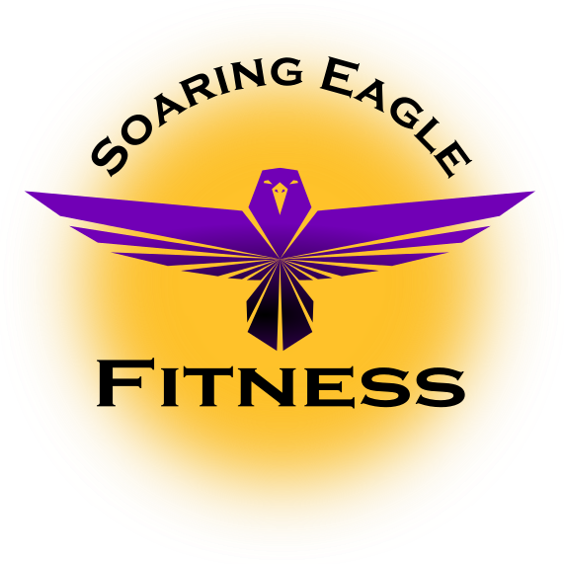

Stretching in The Work Place.

Stretching is the best thing you can do to prevent injury within the workplace. Stretching will loosen the muscles and create more flexibility in the body. With more flexibility, our joints and muscles will have a wider range of motion to prevent injury. You see we use our body as a machine in this field of work, we constantly lift objects well over 40 Lbs., the constant lifting and use of the muscles causes us to become “tight.” This tight feeling is the muscles shortening and in turn becoming “tight.” When our muscles are tight any burst of activity such as picking up a heavy object puts us at immediate risk for muscle strains, muscle damage, and joint injuries. This is because our muscles are unable to fully extend due to them being tight. So, we want to prevent this at all costs! The best prevention? Stretching, it will loosen your tight muscles and is our first line of defense for keeping you safe and injury free! The following is an easy stretching circuit you should perform every morning before work:

Wrist and Ankles: It is very important to stretch your wrists and ankles, while these are not your traditional stretches it is important to loosen them up by rolling them front and back, as well as side to side as pictured.

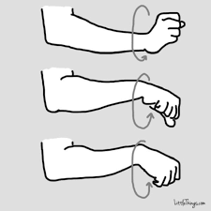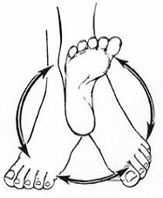
Wrist Rolls Ankle Rolls

Arms: Stretching your Biceps and Triceps is essential to getting your body ready for working at its full potential. When you lift or pull any object your biceps are being incorporated and are one of the first muscles to tighten up due to them being so small. When you push anything, your triceps are being incorporated, much like the biceps they are smaller muscles so they become “tight” faster than other muscles. To stretch the biceps, use the behind the body arm stretch, to do this interlock your fingers and push them away from your back as far as possible. You may also do the wall bicep stretch, you do this by placing your palm flat on a wall and rotating your body away from the wall, this will also stretch your chest. To stretch your triceps, lift your elbow to the sky and use your opposite hand to pull your elbow down towards your spine, this will stretch your triceps, this is also called the behind the head triceps stretch. Another effective movement to stretch the triceps is the across body stretch. This is performed by pulling your elbow across the body, in turn stretching the triceps.

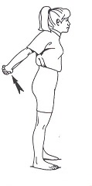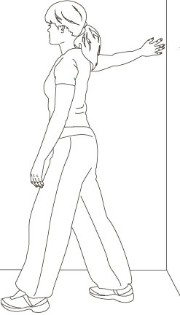
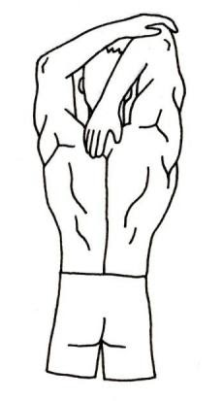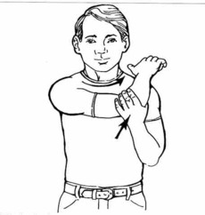
Top Left: Behind body arm stretch, Top Right: Wall bicep stretch, Bottom Left: Behind the head triceps stretch, Bottom Right: Across Body Triceps Stretch

Shoulder Stretches: Shoulder injuries are extremely common, whether it is from pushing or pulling incorrectly, or just a sudden movement. Shoulder injuries can be bothersome and really hinder our day. It is important to keep them loose and flexible to avid discomfort and work and home. Here are a few movements to perform. Perform arm circles, arm huggers and arm swings to pump blood and get your shoulders “warm.” This will get you loose and the blood flow will get your mind stimulated for work. Use the “T” shoulder stretch to isolate your shoulder and really stretch it!

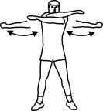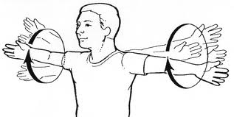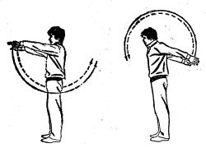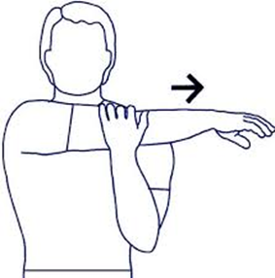
Top Left: Arm Huggers, Top Right: Arm Circles, Bottom Left: Arm Swings, Bottom Right: “T” Stretch

Back Stretches: One of the most common injuries in any field is lower/upper back injuries. The back muscles are utilized in every lift and movement. Along with stretching, be sure to lift with your legs and not your back!

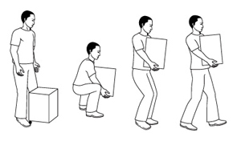
The proper way to lift an object off the floor

To properly stretch your back perform the standing torso rotation, twist your body to one side followed by the other, keep your hips tight and only move your torso. Standing side stretches will loosen up your back as well as stretching key core muscles such as the oblique’s, stand still while lifting one arm to the sky and stretching to one side. Lastly you can do a standing lower back arch, lean your pelvis forward while moving your head and upper body the opposite way.

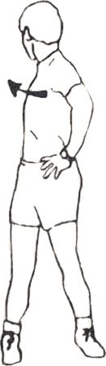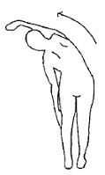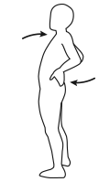
Right: Standing Torso Rotation Center: Standing Side Stretch Left: Lower Back Arch

Leg Stretches: Legs are an important part of the body to stretch, these muscles tighten up often due to the amount they are used. Think about it, you are on your feet most of the day and use them when lifting/walking/running and every other movement. It is important to keep them loose and stretched at all times to avoid pulling one of the many muscles that make up the leg. To stretch your hamstrings, perform the bent over hamstring stretch. Reach your arms down towards your toes and keep your feet straight, get as close to touching the ground as possible. To get the blood flowing to your legs, do the standing leg kicks, this is done by kicking one foot forward and back, the other is planted firmly on the ground (it is important to note it is a slow kick meant to get the body warm). To stretch the hip flexors plant one foot in a lunge position while thrusting your pelvis forward. Lastly to stretch your quad stand with one hand firmly planted on a wall, reach back with the opposite hand and pull your foot towards your body. This is called the standing quad stretch.

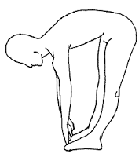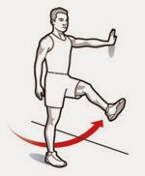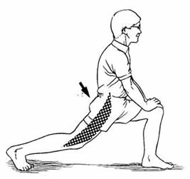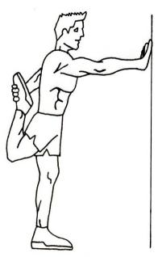
Top Left: Bent over Hamstring Stretch, Top Right: Standing Leg Kicks,
Bottom Left: Kneeling Hip Flexor Stretch, Bottom Right: Standing Quad Stretch

Proper Stretching
- Hold each stretch for 30 seconds
- Stretch for a total of 5-10 Minutes
- Do Not Bounce, this can cause injury
- Stretch the muscles that feel “tight”
- Do not hold your breath during stretches
- You should feel tension not pain
- If you feel pain stop stretching that muscle and seek a doctor’s advice

