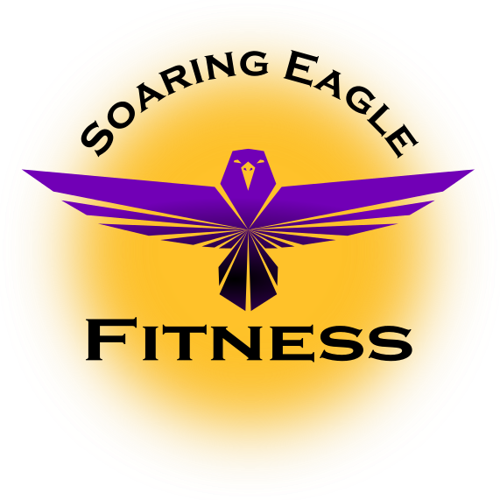

Master Foods List

1. Eat 6 times per day. This, as we discussed, will help boost your metabolism so you will be burning calories and melting fat all day long. This will also help keep your blood sugar stable all day so you will maximize your levels. So make sure you are eating within 1 hour after you get up and every 2.5-3 hours after that.
2. Combine carbohydrates and protein with every meal. Every meal you consume should include proteins and carbohydrates (check listings above). This combination is easier for your body to break down, and wont be stored as fat. This will also help boost your metabolism and energy level.
3. Combine fats with proteins and vegetables. Consuming a combination of fats and carbohydrates together, tends to make it extremely difficult for the body to break them down. With that in mind, for optimum fat loss, it may be best to consume your good fats with carbohydrates in the form of vegetables and some proteins.
4. Appropriate portion size. As we already discussed, we need to make sure you are consuming the right amount of calories for your body. Do not overfeed yourself. Use the palm of your hand for correct portion size.
5. Plan your meals. Make sure that you plan your meals and snacks the day before, as this makes it easier to stick with your food plan and not cheat.
6. Water intake. Its extremely important to stay well hydrated to help build muscle and melt body fat. A good rule of thumb is to drink about 1 gallon to 1.5 gallons per day. You need to drink more if you also consume any caffeine products or diuretics.
7. Staying focused. This is very important in conjunction with getting the results we talked about, and to remind you again that is 70-80% of our results. Every time you think about cheating in your food regimen and/or missing a day of working out, just think for a minute about how you feel about yourself and how you look right now. Are you happy with the way you look/feel? If not, simply don’t do it! Then, think about the goals we set and how great you are going to look and feel once we get there.

Proteins
Chicken breast
Turkey breast
Lean ground turkey
Swordfish
Orange roughy
Steamed haddock
Steamed salmon
Tuna
Crab
Lobster
Shrimp
Top round steak
Top sirloin steak
Lean ground beef
Buffalo
Lean ham
Egg whites
Trout
Low-Fat cottage cheese
Wild game meat

Vegetarian Proteins
Tempeh
Tofu
Soy foods
Veggie burgers

Carbohydrates
Baked potato
Sweet potato
Yams
Squash
Pumpkin
Brown rice
Wild rice
Pasta
Oatmeal
Barley
Beans
Kidney beans
Corn
Strawberries
Melon
Apples
Oranges
Fat-free yogurt
Whole-wheat bread
High fiber cereal
Rice cake
Popcorn
Tortilla
Whole grains

Vegetables
Broccoli
Asparagus
Lettuce
Carrots
Cauliflower
Green beans
Green peppers
Mushrooms
Spinach
Tomato
Peas
Onion
Brussels sprouts
Artichoke
Cabbage
Celery
Zucchini
Cucumber

Fats
Avocado
Sunflower seeds
Pumpkin seeds
Cold-water fish
Natural peanut butter
Low-fat cheese
Low-fat salad dressing
Low-sodium nuts
Olives & olive oil
Safflower oil
Canola oil
Flax seed oil
Fats to Avoid
Butter
Fried foods
Mayonnaise
Sweets
Whole-fat dairy products
Soda

