Workout Card Explanation
My training program uses Borg’s Rate of Perceived Exertion Scale also known as “RPE.” This scale helps to measure how much effort/weight each movement should be performed at. The weight/effort is based on a rating scale of 6-20. The higher the number, the more you are working. For effort the number reflects how high your heart rate should be during the movement, for weight it reflects how heavy the movement should be performed at. The use of this scale makes it easier for you to understand how hard you should be working.
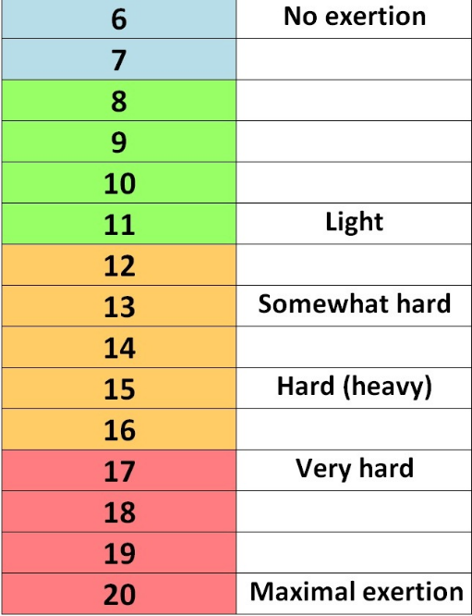
Very rarely will our effort be below 10, only during your cool down phase will your effort be below 10. As shown by the graph, the RPE is the number that will be used on your templates, as you can see there is a breakdown of how intense your movement should be based on your number. 11-13 would be your fat burning zone, 14-16 would be your cardio zone, while 17-20 would be your peak/maximum exertion zone.
Within your program there is a RPE scale to refer to during training, be sure to follow this scale as best as possible for optimal results.
For weight lifting the higher the RPE the more weight for the specified movement. For one person a bench press set of 10 with an RPE 15 may be 225, while others the same movement with an RPE of 15 would be a weight of 145. For this reason I use the RPE to measure your movements instead of giving an actual weight. Be sure to use the proper weight based on your RPE.

How To Write Your Daily Plan
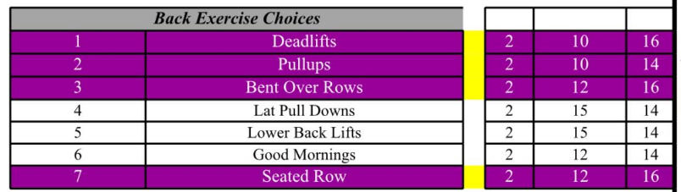
Along with your workout card is a form filled with exercises for specific body parts. Based on the day and the instructions given by me is how you structure your plan for the day. For example, if we met in person and worked chest and triceps you would not perform this on your own unless instructed to. If we meet on a Monday and do not meet Tuesday I will tell you specific body parts to hit, for example Tuesday do back, biceps and abs. You would then create an exercise plan using the movements on the card, you would look at the sections labeled “Bicep Movements,” “Ab Movements” and “Back Movements.” Next to the movements are recommended reps, sets, as well as RPE (see RPE section), these may be altered for reps/sets/weight if needed. I recommend following my suggestions but there are always exceptions. Never over work yourself and keep your overall exhaustion level to a maximum of 9 (Scale of 1-10), I would suggest working yourself to an exhaustion level of 7-8. In order to keep workouts at a maximum time of 45 minutes (excluding Cardio) incorporate super sets. As you can see in the templates, there are 2 different colors, purple or white and appear in sets of 3. They are also numbered this way, this is because I want you to always be doing 3 movements as part of a “super set.” This saves us from being in the gym for 2 hours and ensures we are constantly moving and burning as many calories possible in a limited amount of time.

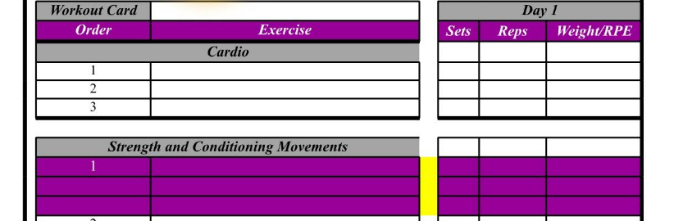
Write down the amount of sets, reps and weight/RPE for every movement, this way we can reflect and see our progress as well as change our current programming if needed. Turn in your cards to me when we meet and reap the benefits of a healthier stronger body!

Read This Before You Start
Before you start be sure to “leave your ego at the door.” It is really easy to injure yourself when performing these movements with more weight than is needed. Always use the appropriate weight and never use more than you can handle. Be sure to use proper form on every movement, if any previous injuries have occurred and you have not stated them to me, please do not perform any movement that could worsen/aggravate the previous injury and contact me right away for suggested movements.

Always perform a warm up before going into any workout. While the cardio is a warm up be sure you are loose and ready to go before performing any movement with an RPE over 12.

